“To acquire wisdom, one must observe.”

Brandeis University’s Community Newspaper

415 South Street — Waltham, Massachusetts 02453
Website: www.brandeishoot.com — Email: eic@thebrandeishoot.com

Advertising Information Packet
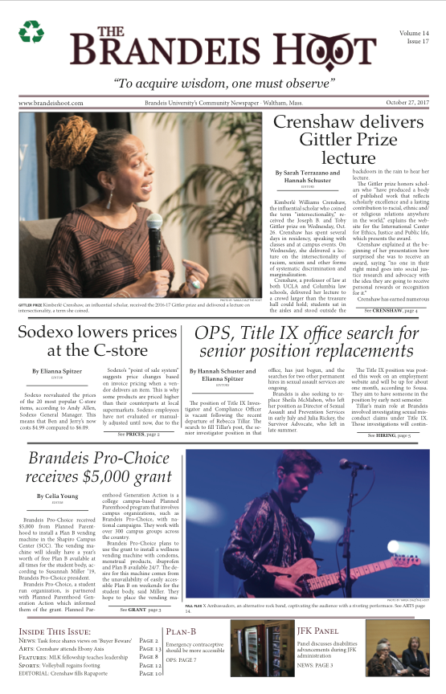
The Brandeis Hoot looks to advertisements to strengthen the connection between the Brandeis Community and the Waltham area - continuing our commitment as “Brandeis University’s Community Newspaper.”

The Hoot was established in 2005, because students felt that Brandeis needed a community newspaper written about, by, and for the members of the Brandeis community. Since the paper’s founding, The Hoot’s growth as a newspaper - doubling in size since its inception - reflects its immediate influence on the Brandeis community. Articles from The Hoot are read worldwide and have been cited by national media outlets including National Public Radio.

The Hoot publishes every Friday during the semester and distributes the newspaper throughout the Brandeis campus and Waltham area. With a distribution of 1,000 to a community of 6,000 students, staff, and faculty, The Hoot is a great, cost-effective way to reach out and connect the Brandeis community to your business.

For more information, please contact our office by e-mail at eic@thebrandeishoot.com

Candace Ng & Polina Potochevska, Editors-in-Chief

Weekly Advertising Rates

Price per Weekly Issue | Black and White | Full Color | Color Back Page
Business Card (3.5" x 1.75") | $25.00 | $30.00 | $35.00
Eighth Page (4" x 5") | $50.00 | $60.00 | $70.00
Quarter Page (5" x 8") | $90.00 | $115.00 | $130.00
Half Page (10" x 8") | $135.00 | $180.00 | $200.00
Full Page (10" x 16") | $270.00 | $350.00 | $395.00

Bulk Rates

4 week Discount  25% off  Four weeks for the price of three | Semester Discount (14 weeks)  28% off  Fourteen weeks for the price of ten
Special Discounts  Non-profit organization—10% off  On-campus organization—25% off  Brandeis students & faculty—25% off | Extra Costs  Guaranteed ad positioning—Add $10

Advertising Contract

Type of Ad | Number of weeks | Price
Discount (if applicable)
Extras (if applicable)
Please make checks payable to Brandeis University, with “The Hoot” in the memo line. | Total
Select Payment Method:

____ Prepaid
____ Bill later

Business Name and Billing Address:

Purchased by:

Phone:

Email:

Signature:

Date:

Special Instructions:
Details

Publication Dates and Deadlines:

We are a weekly Friday publication. All orders must be finalized and advertising copy received by 5pm on the Wednesday preceding the date of publication.

Payment:
Please make all checks payable to Brandeis University with “The Hoot” in the memo line.
(Brandeis Organizations: Chargeline information available upon request.)

Please mail checks to:

The Brandeis Hoot
c/o Polina Potochevska

MB 1105 Brandeis University
PO Box 549110

Waltham, MA 02454

Notes:
All advertising copy is subject to the approval of the Editors-in-Chief. A publication schedule is available upon request.

Technical Information:
The Hoot is a five-column tabloid. Printed by offset on newsprint, each page measures 10 inches wide by 16 inches tall. The line screen is 85 lines per inch. Negatives and reproduction proofs are acceptable. Ads may be sent electronically to ads@thebrandeishoot.com as a TIFF, JPEG, PSD, or PDF. All sizes are listed first by width and then by height.

Discounts:
On-campus rates apply to all Brandeis-affiliated departments, schools, offices, programs, and centers. Non-profit rates apply to organizations that meet the definition of a 501(c) non-profit under US tax codes. Student rates apply to all individual students and to all student organizations registered with the Student Union, Hillel, or the Graduate Student Association.

